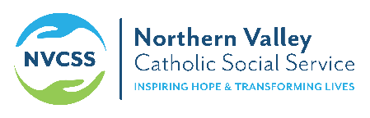 Olberg Wellness Center

RE: Olberg Wellness Center and remote services.

Hello Community Partner,
The Olberg Wellness Center is doing everything possible to keep our community safe and healthy. We are providing remote wellness groups via Zoom M-F from 10a-3pm. Here is the information to log into our groups via Zoom.
If you have computer or smart phone please down load the Zoom App (it is Free)
If you only have a **landline please call: 408-638-0968 (**you will not be eligible for video portion)

You will be prompted to put in the meeting ID#: 8209944650

If you are experiencing technical difficulties and need assistance please call us at 530-247-3321.

We want to encourage everyone to stay informed and updated with credible sources regarding this outbreak:

Cdc.gov/cornonavirus---Center for disease Control for the United states
WHO.int---World Health Organization for world updates
www.co.shasta.ca.us/corornavirus ------ Shasta County Health and Human Services for county updates
https://www.ca.gov/ ------ For the State of California for updates

If you have any questions please call Tina Stephenitch, Supervisor Olberg Wellness Center at 530-247-3321.
Thank you for your support and understanding at this time.

Sincerely,

Tina Stephenitch
Supervisor Olberg Wellness Center

